Chapter 15

Monitoring, Reliability, and Retraining
After reading this chapter, you will be able to:
- Explain why service-level monitoring cannot detect most recommendation-quality failures, and articulate the difference between system availability and recommendation health.
- Define RecSysOps, situate it relative to MLOps, site reliability engineering, and data observability, and explain why feedback loops, exposure bias, catalog churn, and policy-dependent training data make recommender systems harder to operate than most machine learning systems.
- Design a layered monitoring plan that maps each stage of the multi-stage pipeline to its failure modes, its leading and lagging indicators, and the segmentation it requires.
- Localize an observed quality regression to a pipeline stage using stage-level signals, and select an appropriate remediation: model rollback, feature rollback or disabling, index rollback, configuration revert, stage bypass, or degraded mode.
- Reason about drift: distinguish data, concept, preference, catalog, policy, and seasonal drift, explain why a distribution shift does not always cause damage, and explain why stable aggregates can hide severe regressions in a single segment.
- Design a model lifecycle covering retraining triggers, artifact versioning and lineage, validation gates, shadow evaluation, canary release, and champion-challenger operation, including the coordination between model releases and embedding or index refreshes.

15.1 The Dashboard Was Green
Chapter 13 turned the models from Chapters 5 through 8 into a running service, and Chapter 14 made that service fast. Both chapters end at the moment of deployment. This chapter starts the morning after, with the question that occupies most of a recommender system's life: is it still working?
Picture the pipeline from Chapter 13 in steady operation. Retrieval, lightweight ranking, heavy ranking, and the value function have been serving traffic for months. On a Monday morning a product manager asks why engagement on the personalized shelf has been sliding for two weeks. The on-call engineer opens the dashboards. The p95 latency sits inside its budget. The error rate is a rounding error above zero. Throughput tracks the usual weekly rhythm. The feature store answers in single-digit milliseconds. Every service is green, and no alert has fired at any point.
The cause turns out to be three weeks old, a week older than the visible decline. An upstream team migrated the table behind a user engagement aggregate and renamed one of its key columns. The join in the feature pipeline stopped matching and the pipeline substituted its configured default, which was zero. Materialization completed on schedule every night, and the row counts looked normal because the rows were still there. The feature carried no information.
Nothing caught this because nothing was designed to. Zero is a valid floating-point number inside the declared range, so the schema check passed. The Pydantic contract between the orchestrator and the ranking service validated cleanly, since the contract describes shape and says nothing about meaning. The gradient-boosted ranker from Chapter 6 handles missing values natively, and Chapter 13 relied on that handling, or on the contract's defaults, so that a partial feature outage lowers score quality without failing requests (Section 13.4.2). A zero is not a missing value, though, so the model treated it as a real observation and returned a full slate. Every component behaved according to its specification. The recommender kept recommending; it just recommended worse.
This class of failure is invisible to infrastructure monitoring because none of it is an infrastructure event. Chapter 4 described the same phenomenon one layer down, where a data pipeline can run to completion, publish on time, and hand the model values that are quietly wrong, and it opened with the Google Play incident in which features present during training were absent from serving logs while every service appeared healthy (Baylor et al., 2017). More generally, machine learning systems depend on statistical properties of their inputs, and when those properties change the systems tend to fail silently, without the warnings that well-engineered software normally raises (Rabanser et al., 2019).
Netflix frames the operational problem in terms that fit a recommender specifically. Operating a large-scale recommendation system means running many services across many teams in an environment that changes every second, with new members and new items arriving at any time and with new code and new models deployed frequently. In that setting, issue detection is the most critical component because it triggers everything else: a team that cannot see a problem cannot diagnose or fix it (Saberian and Basilico, 2022).
There is a further complication that shapes this whole chapter. Model quality metrics are not the final authority either. Booking.com reviewed roughly 150 customer-facing machine learning applications, each validated through randomized controlled trials, and found that across the model comparisons it analyzed, gains in offline model performance did not track gains in business metrics (Bernardi et al., 2019). A monitoring program therefore has to reach from raw events all the way to user outcomes, and its readings form a set of related signals that must be interpreted together.
Figure 15.1 plots the incident as two groups of signals over the same three weeks.
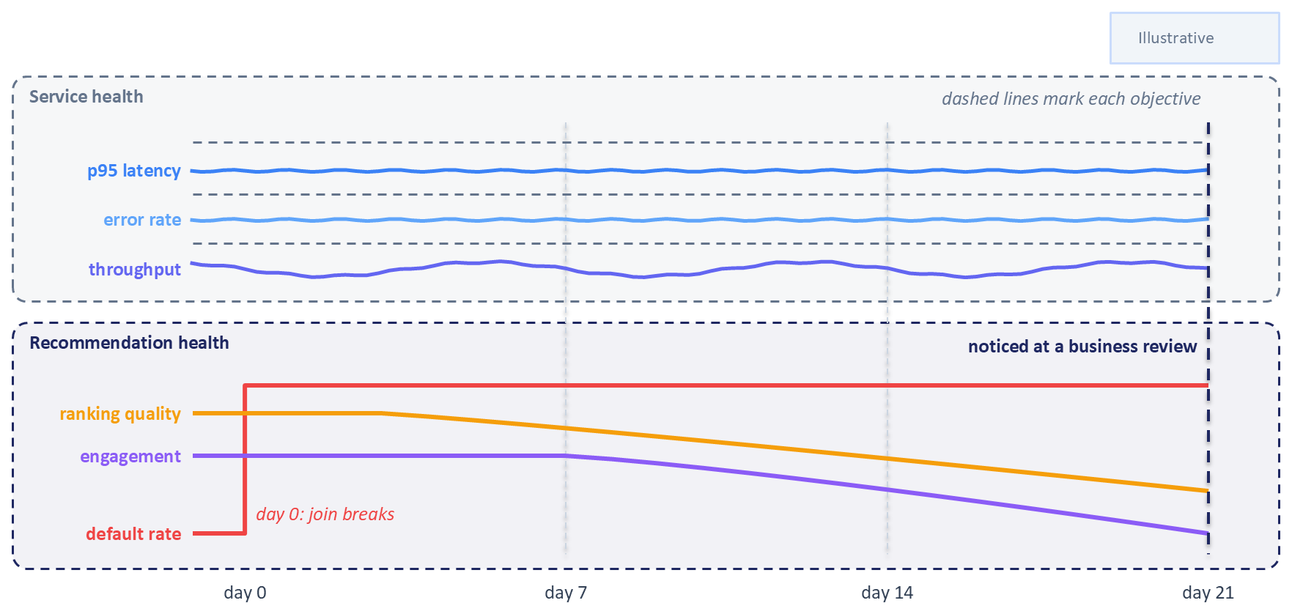
Figure 15.1: A silent feature failure. Service-level indicators stay inside their objectives for all 21 days. In the lower panel the feature default rate jumps on day 0, ranking quality and then engagement decline in turn, and the drop is noticed only at a business review on day 21.
The remainder of the chapter builds the capability that was missing on that Monday morning. Section 15.2 defines RecSysOps and explains why recommenders are unusually difficult to operate, and Section 15.3 introduces the layered model of recommender health that organizes everything that follows. Sections 15.4 and 15.5 work up through the layers to the multi-stage pipeline and show how to localize a regression to a single stage. Sections 15.6 and 15.7 cover change over time and outcomes that arrive late. Section 15.8 turns signals into alerts and incident response, Section 15.9 connects them to retraining and safe release, Section 15.10 covers ownership, and Section 15.11 describes an exercise that reproduces the opening incident on the Chapter 6 ranker.

15.2 RecSysOps and the Production Feedback Loop

15.2.1 Defining RecSysOps
This book uses RecSysOps as a working term for the operational practices that keep recommendation data, features, models, indexes, services, and decision policies healthy over time. The term comes from Netflix, whose engineers introduced it in an industry talk at the 2021 ACM Conference on Recommender Systems to describe the practices they had accumulated for identifying issues and gaps in a large-scale recommender and for diagnosing and resolving them (Saberian and Basilico, 2021).
The word needs one caution. RecSysOps is a working label with no certification, no settled body of practice, and no consensus definition beyond Netflix's original account. It is adopted here because it names something real that existing vocabulary describes poorly.
Netflix organizes the practice into four components, and this chapter borrows that structure for its later sections (Saberian and Basilico, 2022). Issue detection notices that something is wrong in production. Issue prediction anticipates a problem before it reaches production. Issue diagnosis finds the root cause. Issue resolution fixes it, and then improves the operational system so the next occurrence is caught sooner. This chapter widens the fourth component to include the model lifecycle, because in a recommender the resolution of a slow quality decline is frequently a retraining and release decision.

15.2.2 Neighboring Disciplines
Three established practices overlap with RecSysOps, and separating them helps clarify what is new. The first is site reliability engineering, which introduced most of the vocabulary this chapter uses for alerting. A service level indicator, or SLI, is a measured quantity that describes how a service is behaving, such as the proportion of requests answered within 200 milliseconds. A service level objective, or SLO, is a target for that indicator over a defined window, such as 99.9 percent of requests in a rolling 30 days. The gap between the objective and perfection is the error budget, which converts reliability into a quantity teams can spend deliberately on releases and experiments. Site reliability engineering also contributes the principle of alerting on symptoms that users can feel, such as slow or failed requests, and tracing their causes afterward, along with the practice of blameless incident review (Beyer et al., 2016). Readers new to operating production services should treat these ideas as the operational grammar for the rest of the chapter.
The second neighbor is MLOps, which covers the training, packaging, deployment, and versioning of models, and the third is data observability, which watches pipelines and tables for freshness, volume, schema, and distribution problems. Chapter 4 built the data observability foundations that this chapter assumes. Table 15.1 sets the four practices side by side.
Table 15.1: Four overlapping operational practices. They share most of their tools; what sets RecSysOps apart is the object it watches, the quality of the ranked slate as a whole.
Practice | Object of concern | Primary failure signal | Typical detection latency | Usual owner
Site reliability engineering | The running service | Availability, latency, saturation, error rate | Seconds to minutes | Platform and on-call
Data observability | Tables, events, and pipelines | Freshness, volume, schema, distribution | Minutes to hours | Data engineering
MLOps | The model artifact and its lifecycle | Training failures, deployment errors, version skew | Hours to days | ML engineering and platform
RecSysOps | The quality of the recommendations produced | Stage-level and slate-level degradation, drift, feedback effects | Hours to weeks | The recommender team, spanning all of the above

The rows overlap heavily in tooling and often in personnel. They differ in coverage: a team can satisfy the first three rows completely and still ship the incident that opened this chapter, because no indicator in those rows describes whether the ranked list handed to a user was any good.

15.2.3 Why Recommenders Are Unusually Hard to Operate
Four structural properties make a recommender harder to keep healthy than a typical production model, and each one has a monitoring consequence.
The first is that the system trains on data its own past decisions produced. A user can only click something the recommender chose to show, so the interaction logs are a record of the current policy's choices as much as of user preference. Chaney and colleagues simulated communities of users interacting with several families of recommender, and found that training on this confounded data amplified homogenization of user behavior, both across the population and within individual neighborhoods, and amplified the system's effect on the distribution of item consumption, without a corresponding gain in user utility (Chaney et al., 2018). Because the study is a simulation, it demonstrates a mechanism without measuring its size on any deployed platform. Sculley and colleagues had earlier named the same mechanism as a source of technical debt, observing that hidden feedback loops make a model's influence on its own future training data difficult to reason about (Sculley et al., 2015).
The second property follows from the first. An item that retrieval never surfaced has no impressions, and an absence of engagement is not evidence of irrelevance. Treating unobserved outcomes as negative outcomes builds the current policy's blind spots into the next model, and it corrupts monitoring just as thoroughly as it corrupts training. This is why later sections insist on tracking eligibility and coverage as signals in their own right, separately from engagement rates.
The third property is churn. The catalog and the user population turn over continuously, so a model that has not changed at all faces a measurably different problem each week. Cold start is a permanent operating condition in a live recommender, present on every day after launch, and any monitoring plan that reports only aggregate numbers will lose sight of the newest items and users when they most need attention.
The fourth property is that the outcomes used to judge quality arrive late and are themselves shaped by the policy being judged. A click is available in seconds, a completion in minutes, a subscription decision in weeks, and each is conditioned on what the system chose to show. Section 15.7 works through the consequences. Taken together, these four properties explain why importing a generic model-monitoring setup and declaring the problem solved tends to disappoint.

15.3 A Layered Model of Recommender Health
A monitoring plan assembled by adding one metric per incident becomes a large, unstructured collection that nobody can reason about. A more durable approach is to decide in advance which distinct things can be unhealthy, and to instrument each of them. The organizing device used throughout this chapter is a stack of eight layers, running from the raw events that enter the system to the outcomes that leave it.
- Data and event health: the raw interaction and catalog events arriving from upstream systems.
- Feature health: the values assembled from those events and handed to models at training and serving time.
- Model and representation health: the trained artifacts themselves, including embedding tables.
- Retrieval and index health: candidate generation and the approximate nearest neighbor index behind it.
- Ranking and calibration health: the scores produced by the first-stage and second-stage rankers.
- Value function, re-ranking, and business-rule health: the policy layer that turns scores into a slate.
- Serving-system health: the infrastructure concerns owned by Chapters 13 and 14.
- User and business outcome health: what users actually did, and what the business observed.
The ordering follows the path a defect travels, and the symptoms appear at the end of it. Consider an embedding refresh job that stops running without raising an error. The immediate defect sits at layer three, where the item embedding table stops acquiring new entries. Its first visible consequence appears at layer four, as newly published items become unreachable through retrieval and the freshness of candidate sets declines. That propagates to layer six, where a diversity rule struggles to find distinct items to promote, and finally to layer eight, where the users who care most about new content drift away. Throughout, layer seven reports perfect health, because every service involved is answering requests correctly and quickly.
The layers also differ in how quickly they can tell you anything. Layers one through six produce leading signals that are available within minutes or hours and require no labels, since they describe inputs, intermediate artifacts, and the system's own outputs. Layer eight produces lagging confirmation that takes days to mature and is the only layer that speaks directly to whether users were served well. Detection time is bought at the earlier layers and confirmed at the last one, which is why a monitoring program that consists only of business dashboards will always find out too late, and one that consists only of distribution checks will fire constantly without ever establishing that anything was harmed. Figure 15.2 places the eight layers beside the request path of the Chapter 13 pipeline.
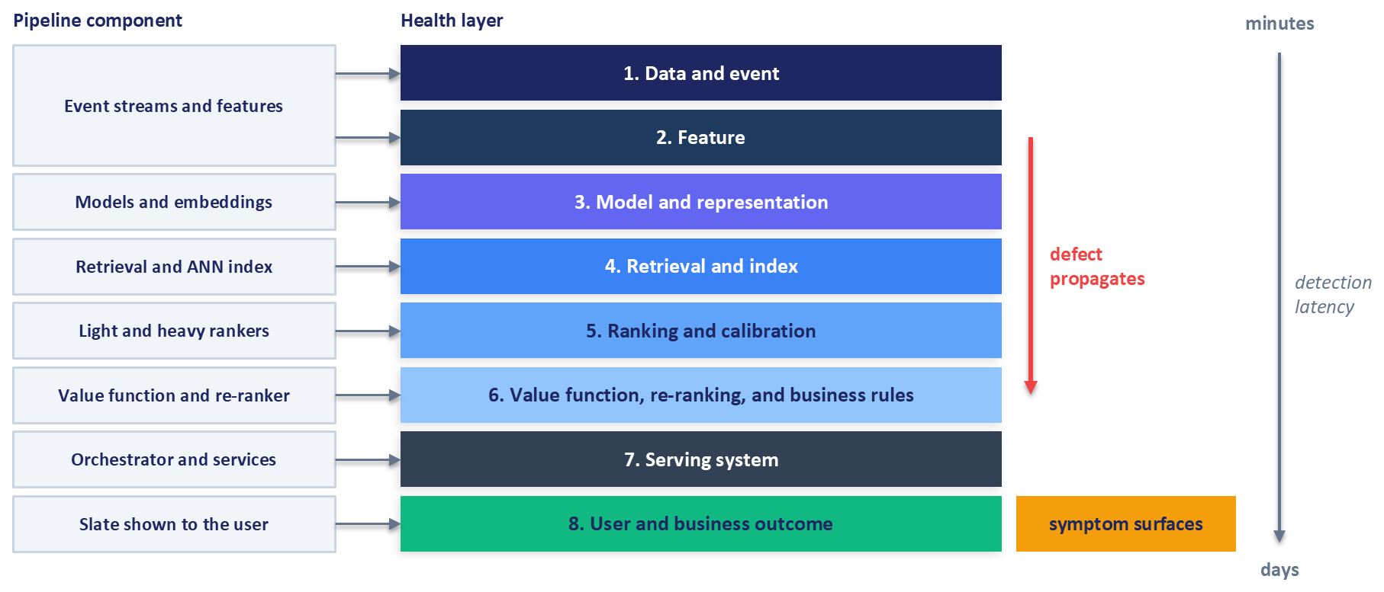
Figure 15.2: The layered model of recommender health, aligned to the multi-stage pipeline. A defect propagates down the stack while its symptom surfaces at the outcome layer, and the typical detection latency grows from minutes at the data and feature layers to days at the outcome layer.
Two lessons from Netflix's account shape how the layers should be instrumented. The first is to audit every input and output from your own team's perspective without relying only on partner teams' audits, because the specific fraction of upstream data your model depends on may not be visible in an upstream team's aggregate checks. The second is to derive detection coverage from the concerns of the people who depend on the system. Netflix describes two such perspectives: from the member side, a case where someone chooses an item the ranking model placed low is a potential issue worth analyzing, and from the item side, the teams responsible for content raised concerns about proper cold-starting and about production bias, which were then turned into metrics and monitoring tools (Saberian and Basilico, 2022).
Table 15.2 condenses the framework into one row per layer.
Table 15.2: The layered monitoring framework in condensed form. Each layer is instrumented independently so that a degradation observed at the outcome layer can be attributed to a specific upstream cause.
Layer | Representative failure modes | Key signals | First diagnostic step
1. Data and event | Missing, late, or duplicated events; renamed columns; broken joins; unit changes | Event volume against baseline; arrival lag quantiles; duplicate rate; join match rate | Walk the lineage to the producing job and compare same-day statistics across sources
2. Feature | Staleness past the freshness objective; default-value fills; distribution shift; training-serving skew | Feature age; null and default rate; distribution distance against a trailing window; online fetch success rate | Recompute the feature offline for sampled keys and compare against the online value
3. Model and representation | Stale artifact; missing embeddings for new entities; incompatible embedding versions; a fault baked into a release | Artifact age against its cadence objective; prediction distribution per version; embedding norms; missing-embedding rate | Pin traffic to the previous version and compare outputs on identical inputs
4. Retrieval and index | Thin or empty candidate sets; a silently failing source in a blend; index staleness; version skew | Candidate count distribution; empty-result and fallback rates; per-source share; index build age; retrieval coverage and freshness | Probe the index directly with known-good queries and compare against exact search
5. Ranking and calibration | Score distribution shift; calibration decay; features unavailable at scoring time; slice regressions | Score quantiles and entropy per version; calibration error as labels mature; per-user metrics; slice dashboards | Replay logged requests through an offline copy of the scorer and diff the results
6. Value function and rules | Configuration pushes; drift in component scores changing the effective trade-off; rule activation spikes; diversity collapse | Per-task score distributions; component contribution shares; configuration change log; rule activation rates | Inspect the configuration audit trail first, then recompute the composite under the previous configuration
7. Serving system | Latency and error regressions; timeout-driven fallback storms; capacity exhaustion | Standard service indicators, plus per-stage fallback activation rate | Check whether fallback rates correlate in time with the quality decline
8. User and business outcome | Engagement decline; diversity erosion; supplier concentration; harm confined to one segment | Engagement proxies by maturation cohort; diversity, coverage, and repetition; segment trend lines | Align the timing of the outcome decline against leading signals from layers one through six

Instrumenting all eight layers at once is rarely realistic. A team starting from the service metrics it inherited from Chapter 13 will get the most immediate value from layer two, because feature defaults and staleness are a common source of silent incidents, as the cases in Chapter 4 show, followed by layer four, because retrieval failures bound the quality of everything downstream and are easy to hide behind a fallback. Layer eight usually exists already in some form, owned by an analytics team, and the work there is to segment its metrics and align their timing with the leading signals.

15.4 Data and Feature Health in Serving
Chapter 4 established the foundations for the first two layers: data contracts that record the assumptions a consumer makes about a feature, schema and constraint validation, point-in-time correctness, freshness objectives with observable timestamps, and comparison of training against serving statistics. This section assumes all of that exists and asks a narrower question. What changes when the consumer of those signals is a live recommender serving traffic?
The main change is that the adversary is corruption that remains syntactically valid. Chapter 4 catalogued the forms this corruption takes upstream and recounted Uber's fares data issue, which went unnoticed for 45 days until someone found it by hand (Shukla et al., 2023). Serving adds one more form and a sharper consequence. A high-cardinality categorical can collapse to a handful of values when an upstream mapping is rebuilt, and no type check notices. At serving time there is also no training job to fail: the model receives well-formed numbers, returns well-formed scores, and the slate is delivered, so the only evidence of trouble lies in what the numbers mean.
The second change concerns what gets measured. A serving system should monitor coverage and eligibility alongside the values that arrived. Coverage asks what fraction of scoring requests actually had a given feature available, which is a different question from whether the feature's distribution looks normal among the requests that had it. A feature can appear perfectly healthy on the subset where it exists while vanishing for a growing share of traffic. DoorDash's prediction service records, for every prediction, which features fell back to a configured default, because its data scientists treated the share of predictions using defaults as a leading indicator of low feature coverage (Chitlur and Csernai, 2021). Eligibility asks which items were candidates at all during a window, and it is the signal that prevents the system from confusing an item nobody was shown with an item nobody wanted. Both connect directly to the exposure problem described in Section 15.2.3.
The third change is that distribution monitoring becomes a routine production activity, and the mechanics introduced here are reused at every later layer. The cheapest signals are the summaries Chapter 4 described, computed on a schedule: null and default rates, a few quantiles for numeric features, the most common categories, and embedding norms. Each is compared against a reference window, typically a trailing period of known-good production traffic or the training distribution itself.
Two comparison methods cover most needs. The Kolmogorov-Smirnov test measures the largest gap between two cumulative distributions and yields a test statistic that can be thresholded or tracked over time. The population stability index is a standard tool of credit-risk model management, where it checks whether the population a model now scores has moved away from the one it was built on (Yurdakul, 2018). It fixes $B$ buckets on the reference data and compares the share of observations in each bucket between reference and current data:
$$PSI=\sum_{b=1}^{B}{(}c_{b}−r_{b})ln⁡\frac{c_{b}}{r_{b}}$$
Here $r_{b}$ and $c_{b}$ are the shares of reference and current observations that fall in bucket $b$. Each term is non-negative, so the index is zero only when the shares match and rises as the distributions separate, and a small floor replaces the share of an empty bucket so that the logarithm stays finite. Yurdakul (2018) points out that its commonly quoted alert thresholds are rules of thumb with no stated error rates, so a team should calibrate them against its own history. Both methods are univariate, cheap, and applied per feature. A study of dataset shift detection found that running a separate univariate test on each output of the model and combining the results performed best of the methods it compared, and that univariate testing in general matched multivariate testing, although its experiments used image classification benchmarks (Rabanser et al., 2019). The reasonable reading for a recommender team is that a modest set of univariate checks on features and on model scores is a defensible starting point.
Whatever the method, the segmentation determines whether the check is useful. A distribution computed over all traffic is dominated by the busiest platform, the largest region, and the most active users, so corruption confined to one mobile client or one country can move the aggregate too little to cross any threshold. Feature monitors should therefore be computed per producing source and per major traffic slice, and the slices should be chosen in advance, before an incident forces a hurried choice.
Section 15.11 describes an exercise that makes this concrete. The two most important non-identifier feature columns in a retrained Chapter 6 ranker are replaced with zeros at serving time, which is the corruption from the opening scenario, and the exercise records which of the signals described here respond and which stay flat.

15.5 Monitoring the Multi-Stage Pipeline
Layers three through six are where recommender monitoring stops resembling generic model monitoring. A multi-stage system has internal interfaces that a single-model system does not, and each interface is both a place where quality can be lost and an opportunity to observe. This section walks the pipeline in request order, then addresses the harder problem of deciding which stage is responsible when quality falls.

15.5.1 Retrieval and Index Health
Retrieval sets an upper bound on everything that follows. An item that is not in the candidate set cannot be ranked, cannot be re-ranked, and cannot be recommended, so a retrieval defect caps the quality of the whole pipeline. It is also one of the easier defects to miss, because the downstream stages continue to return a full slate of plausible items drawn from whatever candidates they were given.
The first signals are the shape of the candidate set itself: the distribution of candidate counts per request, the rate of empty or unusually thin result sets, and the rate of duplicates when several sources are blended. Chapter 13 gave retrieval a fallback to a precomputed popularity list when the service fails or times out, which keeps the user experience intact and simultaneously conceals the failure. The activation rate of that fallback therefore belongs among the first-class monitoring signals, and the same applies to every other fallback in the orchestrator. A system whose graceful degradation is not measured will degrade gracefully all the way to uselessness without complaint.
When candidates come from a blend of sources, the share contributed by each source needs its own time series. A single source failing inside a blend rarely produces an empty result, since the remaining sources fill the quota, and the resulting slate is subtly narrower with nothing obviously broken.
Two coverage signals describe whether retrieval is reaching the catalog. Retrieval coverage is the fraction of eligible items that appeared in any candidate set over a window, and it tends to decline slowly as a system becomes more confident and more concentrated. Candidate freshness is the age of the newest items appearing in candidate sets, and it is the leading indicator for cold-start problems, because it falls the moment new content stops reaching the index while every other signal remains normal.
Index health needs particular attention in a two-tower system. The query tower (Chapter 13's user tower), the item embeddings, and the approximate nearest neighbor index built from them form a single compatibility unit. The query tower produces a query vector in the embedding space defined by the model version that trained it, and the index answers in the space of the model version that produced its vectors. When those versions diverge, every lookup returns confident, well-formed, meaningless results. Distances remain finite and the service stays fast. The relevant monitors are the age of the index build, the model version recorded in the index manifest compared against the version loaded by the serving tower, and the fraction of catalog items with no embedding in the index. Chapter 13 described two refresh strategies, a scheduled full rebuild and streaming upserts for new items, and the choice sets the floor on how stale the index can become.
Detection is not the only option at this layer. Netflix reports building a model that predicts the behavioral statistics of the production model on an item's launch day, using historical data, which allowed the team to identify likely cold-start problems a week or more before the item reached the service and to fix them in advance (Saberian and Basilico, 2022). This is the issue prediction component of RecSysOps, and retrieval is where it is most tractable, because the conditions that cause a new item to be unreachable are visible before any user is affected.

15.5.2 Ranking and Calibration Health
The ranking stages convert candidates into scores, and their health is characterized primarily through the distribution of those scores. Tracking the mean, a few quantiles, and the entropy of the score distribution, computed over a fixed set of score bins, for each deployed model version gives a compact and sensitive signal. A compressed distribution suggests the model has lost access to a discriminating input, which is what happens when a feature silently fills with defaults. When only part of the traffic is affected, the mixture of healthy and damaged scores can widen the distribution instead, so a change in spread in either direction calls for investigation. A shifted distribution with unchanged spread more often indicates a change in the population being scored. Because these are properties of the model's own output, they require no labels and are available immediately.
Calibration needs separate treatment because a multi-stage recommender depends on it structurally. A model is calibrated when its predicted probabilities match observed frequencies, so that items assigned a score of 0.2 are engaged with about twenty percent of the time. Chapter 7 introduced calibration for the multi-task heads whose probabilities feed the value function, and Chapter 9 added expected calibration error, the average gap between predicted probability and observed frequency across bins of predictions, in the advertising setting where predicted probabilities feed directly into prices. The value function from Chapter 8 is where the dependency bites: it blends several task probabilities into one composite, so if one head becomes miscalibrated relative to the others, the effective weighting of the objectives changes even though nobody edited the weights. Modern neural networks are known to be systematically miscalibrated in ways that accuracy metrics do not reveal (Guo et al., 2017), which makes calibration a production signal to track over time; a single check before launch says little about next month. Calibration monitoring depends on labels and therefore matures on the schedule described in Section 15.7.
The ranking stage is also where feature problems become visible as behavior. The rate of failed or partial feature hydration at scoring time, meaning the feature-store lookup that Chapter 13 performs before each scoring call, broken down by feature, connects layer two directly to layer five and is often the fastest route from a quality alert to a data root cause.
Finally, ranking metrics must be segmented before they are trusted. Chapter 9 introduced group AUC, computed separately for each user and then averaged, as a more faithful measure than a global AUC when a small number of highly active users supply most of the interactions. The same reasoning applies to production monitoring with more force, because the aggregate is the number a dashboard shows by default. A regression confined to new users, to a single device platform, or to the long tail of the catalog can be severe in its own segment while moving the overall figure by an amount indistinguishable from noise.

15.5.3 Value Function, Re-ranking, and Business-Rule Health
The policy layer built in Chapter 8 and deployed in Chapter 13 contains, as Chapter 13 noted, no trained weights, so its failures take two forms: the configuration changed, or the inputs to the configuration changed.
The first form is easy to detect and frequently overlooked. Because Chapter 13 made the value function configuration hot-reloadable, a file upload is a production deployment, and it should be logged, versioned, attributed to a person, and shown on the same timeline as code deployments. When a quality metric moves sharply, the configuration audit trail is the cheapest thing to check and should be the first.
The second form is subtler. The composite value is a blend of several task probabilities, so the contribution share of each component is a meaningful quantity: the fraction of the final composite attributable to the listen term, the like term, the play-ratio engagement term, and the dislike penalty. Those shares should be stable in the absence of a deliberate change. When one head drifts or becomes miscalibrated, the shares move, and the system quietly begins optimizing a different objective than the one the team believes it configured. Monitoring contribution shares catches this while the individual model metrics still look acceptable.
Business rules provide unusually cheap signal because their activation is discrete and countable. The rate at which an artist pacing rule, a supplier cap, or a slot requirement actually binds tells you something about the distribution of what arrived from upstream. A sharp rise in how often a pacing rule fires usually points upstream, for example to retrieval returning a narrower set of artists, and the rule itself is rarely at fault. A sharp fall can mean the rule has stopped being applied at all.
One compact monitor summarizes the whole stage. Compute a rank correlation, such as Kendall's tau, between the ordering produced by the ranker and the ordering after the value function, diversity re-ranking, and rules have been applied. That single number describes how much the policy layer is reshaping the slate, and a substantial move in it, in either direction, warrants investigation even when every other metric holds steady.

15.5.4 Outcome and Slate Health
The final layer covers what the user received and what happened next. Engagement metrics belong here, subject to the label timing described in Section 15.7, but so do the properties of the slate itself, which can be measured the moment it is produced and require no labels at all.
Chapter 3 and Chapter 8 introduced the beyond-accuracy family of measures, and a survey of these objectives provides the standard definitions and their empirical behavior (Kaminskas and Bridge, 2016). Tracked as production time series, the most useful are intra-list diversity, which describes how different the items within a single slate are from one another; catalog coverage, which describes how much of the catalog is being recommended to anyone at all; novelty, which describes how unfamiliar or unpopular the recommended items are; and repetition, which describes how often the same items reappear for the same user across sessions. Concentration measures complete the picture, particularly the share of impressions going to the most-recommended items or to the largest suppliers, artists, or sellers.
These quantities move slowly, and that is the reason to watch them. A ranking regression announces itself in hours. The narrowing described by Chaney and colleagues, in which the recommender progressively homogenizes what people see, unfolds over weeks and is entirely compatible with healthy engagement rates in the short term (Chaney et al., 2018). Slate-health metrics are the instrument for that slower failure, and they also let a team notice when a change made for good reasons at one stage has reshaped what the catalog offers.

15.5.5 Localizing a Regression to a Stage
Suppose an outcome metric has fallen and the decline is real. The pipeline has four candidate culprits and each can mask the others. A ranker that is performing well can partly rescue a degraded candidate set by making the best of what it receives, so a retrieval failure shows up as a small outcome decline with no obvious break. In the other direction, a healthy retrieval stage keeps supplying good candidates while a broken ranker orders them badly, and the final click-through rate falls by less than the ranking damage would suggest because good items are still present somewhere in the slate.
Localization requires that the intermediate state was recorded. Netflix is explicit that reproducing an issue in a large-scale recommender by rerunning the code is usually impossible, because the input data and feature values have already changed, so the logging needed to reproduce a problem has to be in place before the problem occurs. That means logging the candidate set, the request context, the feature values, and the serving model identifier for a sampled fraction of traffic, and designing the sampling so that every important slice retains sufficient coverage (Saberian and Basilico, 2022). Sampling is what makes this affordable; slice-aware sampling is what makes it useful.
With that logging available, one technique localizes many regressions. For interactions where the user engaged with an item, trace that item backward through the stages and record where it stood at each one. If the chosen item was absent from the retrieval output, retrieval is implicated. If it was present in the candidate set but ranked poorly by the scorer, the ranking stage is implicated. If the ranker placed it near the top and the final slate demoted it, the value function or the business rules are implicated. Aggregating this attribution across many interactions turns a vague quality complaint into a distribution over stages, and the stage whose share has changed is the one to investigate.
The second technique is replay. Take the logged inputs for a sample of past requests, run them through an offline copy of a single stage at the current version, and compare the output against what was served. Differences isolate the stage under test while holding its inputs fixed, which distinguishes a stage that changed from a stage that merely received different data. Applied stage by stage, replay converts a system-level regression into a specific artifact and a specific version. Figure 15.3 orders the stage checks from Sections 15.5.1 to 15.5.3 by cost, cheapest first, and ends with replay; the backward trace indicates which branch to examine first.
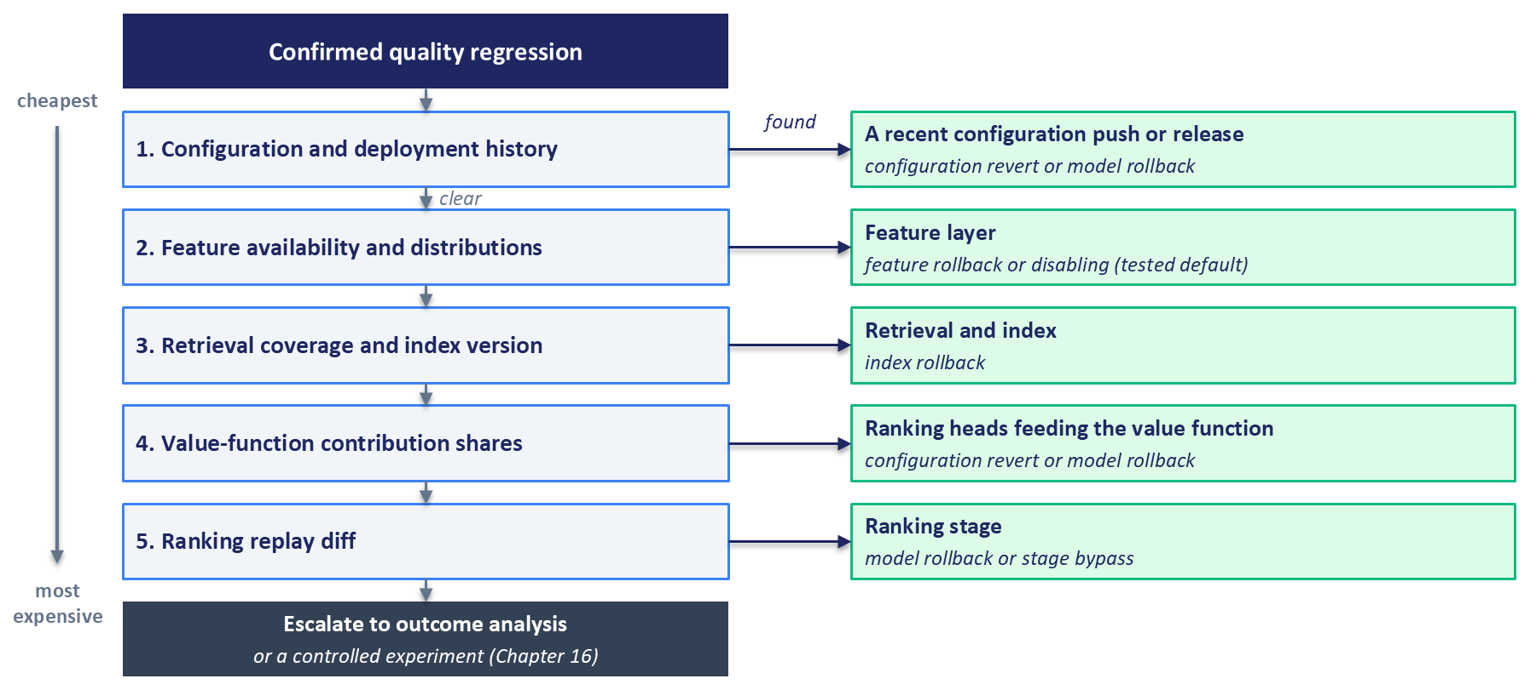
Figure 15.3: Stage localization flow. Five checks run from cheapest to most expensive, starting with the configuration and deployment history and ending with a replay of the ranking stage. A positive finding at any check names the implicated stage and its remedy from Section 15.8.4; a clear result passes to the next check, and a regression that clears all five goes to outcome analysis.

15.6 Drift and Degradation
Teams use the word drift for almost any unwelcome change over time, which makes the word unhelpful during an incident. Separating the kinds of change clarifies both what to measure and what to do, because the appropriate response differs sharply between them. Table 15.3 sets out the distinctions used in this book.
Table 15.3: Kinds of change in a production recommender. The response column carries the operational weight, because several of these changes are expected conditions that need no repair.
Kind of change | What changes | Typical cause | Representative signal | Response
Data drift | The distribution of model inputs | A new client version, a new market, an upstream schema or logging change | Distribution distance on features against a trailing reference window | Establish whether the source changed or the population changed before acting
Concept drift | The relationship between inputs and outcomes | Users respond differently to the same context than they used to | Quality and calibration decline while input distributions hold steady | Retrain on recent data; consider shortening the training window
Preference drift | What users want | Trends, life events, external events | Segment-level engagement shifts, often gradual | Retrain on a schedule matched to how fast preferences move
Catalog drift | The item population | Launches, removals, changes in supply or licensing | Item age distribution, retrieval coverage, missing-embedding rate | Refresh embeddings and the index; check cold-start handling
Policy drift | The system's own behavior, and therefore its training data | A model release, a configuration change, a promotion, a new rule | Component contribution shares, rule activation rates, exposure concentration | Check release and configuration history first; this is often intended
Seasonal variation | Everything, on a recurring schedule | Time of day, day of week, holidays, annual cycles | Recurring patterns visible in most metrics | Model the pattern into the baseline and do not alert on it

The academic literature on adaptive learning distinguishes real drift, in which the conditional relationship between inputs and the target changes, from virtual drift, in which only the input distribution moves while that relationship holds. The survey by Gama and colleagues gives the standard treatment along with a taxonomy of change-detection methods (Gama et al., 2014). The distinction earns its place because the two demand different responses. Virtual drift means the model is being asked about a different population and may still be entirely correct about it. Real drift means the model's learned relationship has expired.
Policy drift is the row with no equivalent in most machine learning systems. A recommender intervenes in the world it measures. When a team ships a new ranker, changes a value function weight, or launches a promotion, the distribution of what users see changes by design, and every downstream metric moves as a consequence. Much of what gets reported as mysterious drift is a colleague's deliberate change observed from the far end of the pipeline, which is why release and configuration history belongs on the same timeline as the metrics.
Change also arrives at different resolutions. Global drift affects all traffic and is the easiest to see. Segment-specific drift affects one platform, region, or user cohort, and can be invisible in the aggregate for the reasons discussed in Section 15.5.2. Long-tail degradation affects the least popular items and the newest users, which are small populations that contribute little to any total, so a system can lose the tail entirely while its headline numbers improve. Cold-start slices sit permanently at this frontier, since the population under evaluation is new by definition and never settles into a stable distribution.
The most consequential point in this section is that detecting a distribution change is not the same as establishing harm. Work on shift detection makes this separation explicit, treating the question of whether a shift occurred and the question of whether that shift is malignant as distinct problems, and finding that domain-discriminating approaches help characterize a shift qualitatively and judge whether it hurts (Rabanser et al., 2019). A drift alert should therefore open an investigation, and retraining waits until the investigation shows harm. The triage question is whether the quality and calibration signals at layers five and eight moved alongside the input distribution. If they did not, the system may be handling the new population correctly, and retraining on the basis of the alarm alone spends compute and adds release risk without a demonstrated benefit.
Two production accounts illustrate how this is handled at scale. LinkedIn built model monitoring into its central machine learning platform so that each team no longer had to build its own. Feature values computed at inference time are tracked, a daily job computes statistics over them, and a significant change in distribution raises an alert to the model's engineers. The same machinery is available during a pre-production stage that LinkedIn calls a dark canary, where problems can surface before the model is ramped to serve members (Kumar et al., 2021); Section 15.9.5 returns to this kind of stage. DoorDash, facing models that begin degrading as soon as they are deployed, generates metrics automatically from prediction logs for every model on its platform, so that data scientists get monitoring and alerting without writing bespoke code (Chitlur and Csernai, 2021).
A single seasonal example exercises most of the table. A music service approaching a holiday period sees new seasonal releases enter the catalog, which is catalog drift. Listening patterns shift toward that material, which is preference drift and also seasonal variation, since it will reverse in January. The team runs a promotion that boosts seasonal content, which is policy drift and changes the training data for the next model. Input distributions move substantially throughout, which is data drift. None of this is a defect, and a monitoring setup that pages someone for each of these movements will be ignored by the time an actual defect arrives.

15.7 Ground Truth Arrives Late
Every quality signal that depends on what a user did carries a timing problem. The system produces a slate instantly, and the evidence about whether that slate was good accumulates over hours, days, or weeks. Any dashboard that ignores this will misreport recent periods in a consistent direction, and any alert threshold that ignores it will fire on the shape of the delay, whatever the quality of the recommendations.
Outcomes form a chain, and each step trades timeliness against meaning. An impression is known immediately and says almost nothing. A click follows within seconds and says a little. A completion, a purchase, or a listen-through arrives within minutes to hours and says more. Retention and subscription outcomes arrive weeks later and are closest to what the business actually wants, by which time the model that produced the recommendation may have been replaced twice. Monitoring uses the early links because they are available, and interprets them in light of the later ones.
An outcome that has not occurred yet is best treated as censored, meaning unresolved. Chapter 9 introduced this in the advertising setting, where conversions can follow a click by days or weeks, and where treating every unconverted click as a negative example biases the model badly. The standard treatment models the delay jointly with the outcome, so that a click with no conversion is treated as a negative when enough time has elapsed relative to the expected delay and set aside as unresolved when it is too early to tell (Chapelle, 2014). Monitoring inherits the same logic. A metric computed over yesterday's traffic measures only the portion of yesterday's outcomes that had matured by the time the query ran.
Three operational habits follow. The first is to compute quality metrics per maturation cohort, so that today's reading for a seven-day metric is compared against the same seven-day reading for earlier cohorts, never against a fully matured figure. The second is to give every dashboard explicit as-of semantics, stating both the traffic window and the observation cutoff, and to recompute and backfill historical points as labels arrive, so that no chart keeps the first value it wrote. The third is to set alert thresholds that account for expected incompleteness, or to suppress alerting entirely on the immature portion of a metric, because a partially observed conversion rate is low for reasons that have nothing to do with the recommender. Figure 15.4 shows what happens when a fresh reading meets a fixed threshold.
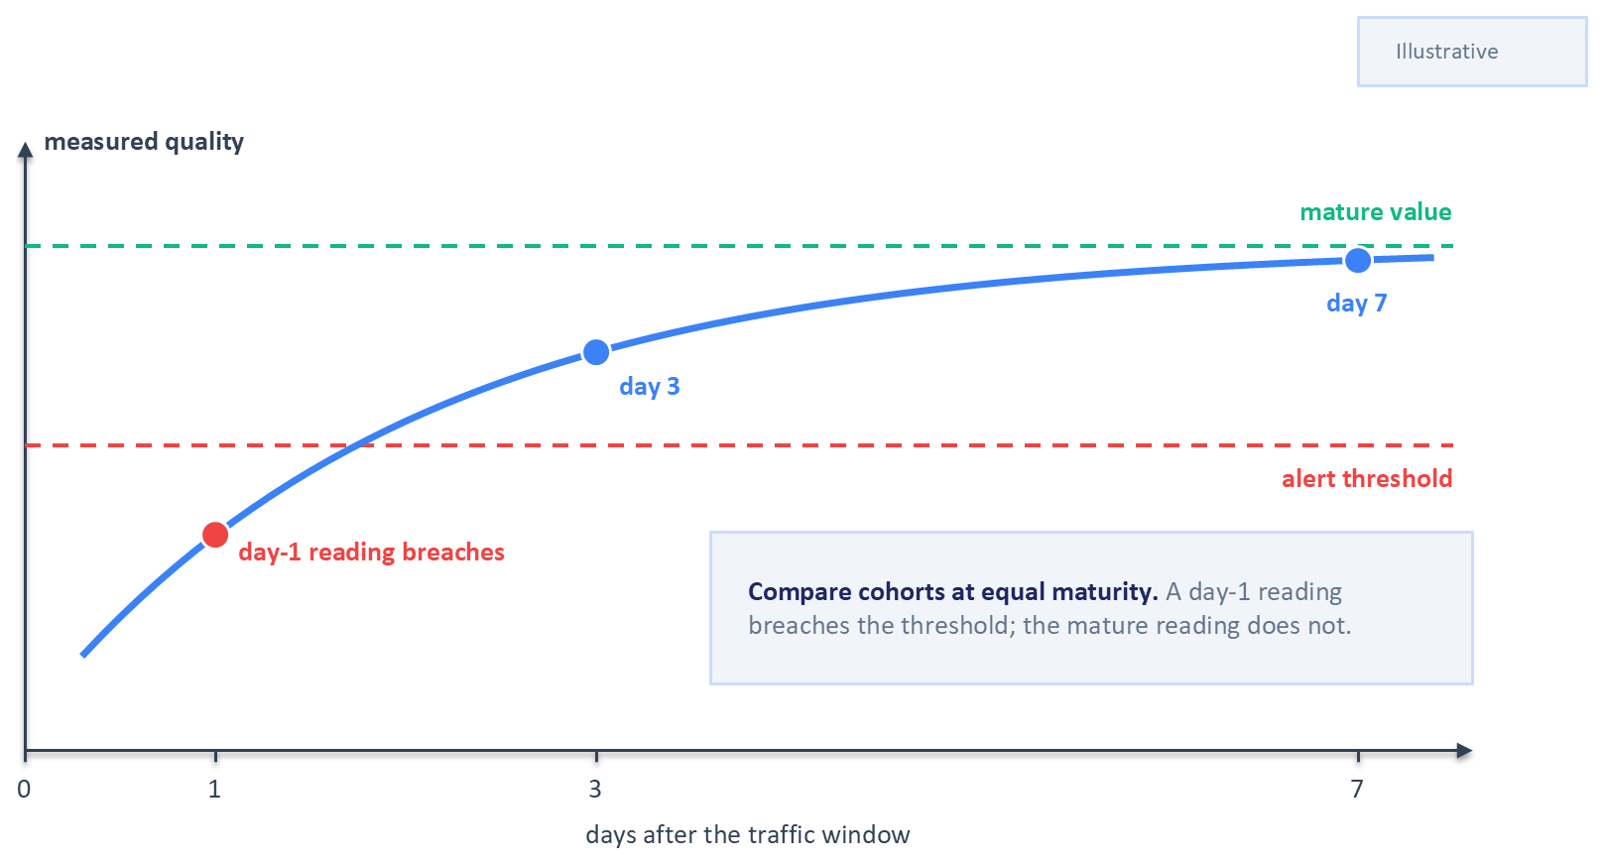
Figure 15.4: Label maturation. The measured quality of one day's traffic rises as its labels arrive. Read on day 1, it falls below the alert threshold; read on day 3 or day 7, it sits above it, which is why cohorts must be compared at equal maturity.
Booking.com describes operating under this constraint, monitoring the signals that are available quickly while complete feedback is still accumulating, and treating the distribution of model responses as a monitorable object in its own right, which gives feedback as soon as a few predictions have been made (Bernardi et al., 2019). That reinforces a theme from Section 15.3: the label-free signals at the earlier layers are what make timely detection possible, and the outcome layer is what eventually confirms or refutes the interpretation.
One limitation cannot be engineered away within this chapter. Monitoring based on user behavior evaluates the policy using data that the policy itself generated. Items the system never showed produce no evidence, so degradation in the regions of the catalog that the current model has stopped exploring is invisible by construction, and improving the metric can coexist with a narrowing of what the system is capable of discovering. The partial mitigations available here are the coverage and eligibility signals from Section 15.4 and the slate-health metrics from Section 15.5.4, both of which describe what the system did, independent of how users responded. The principled remedies, deliberate exploration and off-policy evaluation, belong to Chapter 16.

15.8 Alerts, Diagnosis, and Incident Response
Signals become an operational capability only when someone is told about them, knows what to do, and is able to do it quickly. This section turns the preceding measurements into objectives, alerts, a diagnostic procedure, and a set of prepared responses.

15.8.1 From Metrics to Objectives
The availability and latency targets set in Chapters 13 and 14 describe the serving system. A recommender needs a small number of additional objectives that describe recommendation health, chosen so that each layer of the framework has at least one representative. A workable starting set is the feature availability and default-fill rate at scoring time from layer two, counting defaults substituted upstream where the pipeline records them (Section 15.4), the rate of empty or fallback-served candidate sets from layer four, a bound on calibration error from layer five, and a floor on slate diversity from layer six. Each becomes a service level indicator with a target and a window, and the shortfall each is permitted forms an error budget in the same sense used for availability (Beyer et al., 2016).
Keeping the set small is deliberate. Every objective creates an obligation to respond, and a team with thirty objectives has none, because it cannot treat any of them as binding. The remaining measurements from Sections 15.4 through 15.6 still belong on dashboards and in weekly review; they simply do not page anyone.
Separating alert severities enforces that discipline. A paging alert wakes someone and should be reserved for conditions that are both user-visible and actively getting worse, such as a sustained spike in fallback-served requests. A ticketing alert creates work for the next business day and suits conditions that are real but slow, such as a feature drifting past its reference window. A dashboard signal informs investigation without demanding action.

15.8.2 Thresholds, Seasonality, and Alert Fatigue
Chapter 4 noted that static thresholds suit firm invariants, such as a probability outside the range from zero to one, and the same holds here for an index older than its rebuild interval or a missing model version, checks that never need tuning.
Most recommender signals have no such fixed bounds. Traffic composition varies by hour and weekday, catalogs change on release schedules, and engagement follows seasonal patterns, so a fixed threshold on any of these produces alerts that correlate with the calendar. Adaptive baselines address this by comparing a signal against its own recent history at the equivalent point in the cycle, comparing this Sunday with previous Sundays. Alerts built this way are quieter, and they carry the risk that a slow degradation is gradually absorbed into the baseline, which is why they should be paired with a long-horizon comparison against a fixed reference period.
Alert fatigue is the characteristic failure mode of monitoring itself. A team that receives frequent alerts it cannot act on will stop reading them, and the eventual real alert arrives in a channel nobody trusts. The organizational cure is ownership. Chapter 4 made the point at the feature layer that monitoring with no defined response path produces only dashboards, and it applies with equal force here. Every alert should name an owning team, a severity, and a documented response before it is enabled. An alert that cannot be given all three should be a dashboard signal.

15.8.3 Diagnosis
Diagnosis begins by reproducing the issue in isolation. In a live recommender that depends on the sampled per-stage logging described in Section 15.5.5, because rerunning yesterday's code today meets features, a catalog, and a candidate pool that have all moved (Saberian and Basilico, 2022).
The next question is whether the fault lies in the model's inputs or in the model itself, and inputs are checked first because they are cheaper to inspect. Validating a feature value in absolute terms is difficult, since many features are complex aggregates and some are the outputs of other models. Netflix reports a simple and effective substitute: compare the suspect feature value against the corresponding value for a comparable item or member, which establishes whether the value is in a plausible range without needing to trace it to its source. That technique surfaced abnormal values in an item's language features, which turned out to originate in a misconfiguration in an upstream database (Saberian and Basilico, 2022). When inputs check out, the same team turns to the model and its training data. Their tools include general attribution methods such as SHAP (Shapley additive explanations), which assigns each feature a share of an individual prediction (Lundberg and Lee, 2017), alongside architecture-specific checks such as visualizing the nodes of a tree model. That approach led them to a bug in missing-value handling in one case and to a faulty segment of training data in another.
Lineage is what turns a localized anomaly into a list of suspects. Data lineage answers which upstream job produced the affected values and which other consumers are affected, and model lineage answers which training run produced the deployed artifact, on which data window, with which feature definitions. Chapter 4 built the data side. The model side is covered in Section 15.9.3, and the two together determine whether an incident takes an hour or a week.

15.8.4 The Remediation Menu
Hotfixing a machine learning model is awkward in ways that hotfixing application code is not. The model is a highly optimized artifact, retraining takes time, and hand-editing its behavior tends to produce suboptimal recommendations. Netflix's response to this is to prepare a menu of hotfix strategies in advance, each with its trade-offs quantified, so that during an incident the team selects a response it has already designed (Saberian and Basilico, 2022). Switching to a different artifact is usually safer than editing one.
A recommender built along the lines of Chapter 13 has six such options. Model rollback returns to the previous version through the rollback path of Section 13.10, and it is fast when versioning is disciplined, at the cost of losing whatever the new model improved. Feature rollback or disabling deals with a corrupted input. Disabling removes the input from the model's view, which is safe only when the model and serving code define a tested default for that feature, a precondition Chapter 4 insisted on and one best verified before an incident. When the default itself is the fault, as in the opening incident, the remedy is to restore the last known good materialized values, which Chapter 4 asked the release process to preserve, and the upstream fix and backfill follow. Index rollback restores the last known good snapshot and is the right response to a bad embedding refresh, provided snapshots are retained. Configuration revert undoes a value function or business rule change and is usually the fastest action available, since moving Chapter 13's configuration pointer back restores the previous version at each replica's next poll (Section 13.6.2). A corrective configuration that has never served traffic is a new release, so it is validated and rolled out in stages through Section 13.10 like any other configuration change. Stage bypass falls back to a simpler upstream output, such as serving the lightweight ranker's scores when the heavy ranker is suspect. It turns two automatic mechanisms into deliberate incident tools: Chapter 13's degradation ladder, which the orchestrator descends when a stage fails, times out, or sits behind an open circuit breaker (Section 13.8.5), and the budget- and load-triggered levels Chapter 14 adds to it (Section 14.9.3). Degraded mode falls back to non-personalized popularity lists, which is the floor of acceptable service and should be exercised occasionally so that it is known to work.
Each option should have a documented blast radius, meaning the share of users or traffic it affects, and a documented cost in recommendation quality, decided calmly and written down, because the moment of the incident is the worst time to estimate either.

15.8.5 After the Incident
The review that follows an incident should be blameless in the sense established by site reliability practice. It examines the conditions that allowed the failure and leaves aside the question of who triggered it, since a review that assigns fault reliably reduces the information available at the next one (Beyer et al., 2016).
For a recommender the review has a specific agenda drawn from the RecSysOps loop. Could the issue have been detected earlier, and if so, which signal was missing? Could it have been predicted before it reached production? Could diagnosis have been faster, and which logging or tool would have made it so? Netflix's summary of this component is that every incident should leave the operational system better than it found it, and that the system should be as frictionless as possible: checks run automatically on a schedule, the information a human needs is assembled before judgment is required, and deploying a prepared hotfix takes a couple of clicks (Saberian and Basilico, 2022). Figure 15.5 replays the opening incident with and without layered monitoring.
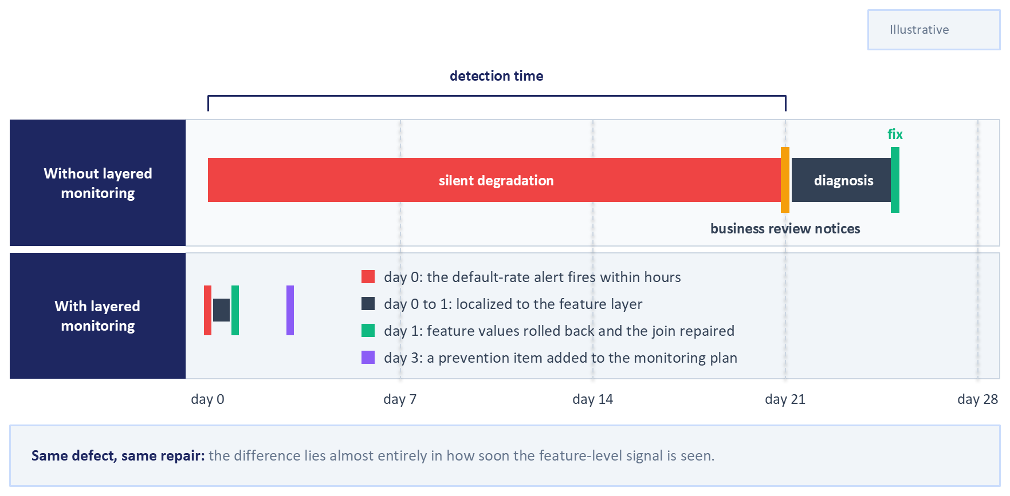
Figure 15.5: The same incident with and without layered monitoring. With feature-level monitoring, the default-value alert fires on the day the join breaks and the incident closes within days; without it, the decline is noticed in the business metrics weeks later. The difference lies almost entirely in detection time, which is the quantity the earlier layers exist to reduce.

15.9 Retraining and Lifecycle Management
Monitoring produces evidence, and evidence eventually demands a decision about the artifacts themselves. This section covers when to retrain, when retraining is the wrong response, what has to be versioned for any of it to be reversible, and how a new model or index reaches production without breaking the system.

15.9.1 Deciding When to Retrain
Three families of trigger are in common use, and mature teams combine them. Table 15.4 compares how each fires and where each falls short.
Table 15.4: Retraining triggers compared. Most production systems run a schedule as the floor and layer event and performance triggers on top of it.
Trigger | How it fires | Strengths | Weaknesses
Scheduled | A fixed cadence, such as nightly or weekly | Predictable cost and capacity; simple to operate; bounds staleness by construction | Retrains when nothing has changed and waits when something has; cadence is guesswork without measurement
Event-triggered | A known event, such as a catalog launch, a market opening, or an upstream migration | Aligns model updates with the changes that actually invalidate them | Only covers events someone anticipated and wired up
Performance-triggered | A monitored signal crossing a threshold, such as calibration error or a quality metric | Responds to the measured condition of the system itself | Depends on signals that may be label-delayed; risks reacting to drift that causes no harm

Chapter 4 already established that freshness has measurable value, through ByteDance's Monolith results on parameter synchronization intervals (Liu et al., 2022) and Grubhub's comparison of retraining cadences (Egg, 2021), and those numbers are not repeated here. The operational point for this chapter is the sequencing. A retraining run inherits whatever is wrong with its input data, so the data and feature health checks from Section 15.4 should pass before a retraining job starts, and a job that begins while a feature is filling with defaults will produce a model that has learned to expect defaults.

15.9.2 When Retraining Is the Wrong Response
Retraining is attractive during an incident because it is a well-understood action that can be started immediately, which is also why it gets misapplied. When the root cause is a pipeline defect, a serving bug, an index that failed to refresh, or a configuration change, retraining does not address the cause. At best it wastes a cycle. At worst it produces a model fitted to corrupted inputs, replaces a healthy artifact with a compromised one, and destroys the clean comparison that diagnosis depends on. The ordering is therefore diagnosis first, lifecycle action second.

15.9.3 Versioning the Whole System
Rollback, reproduction, and root-cause analysis all depend on being able to name and retrieve the exact artifacts that were serving at a given moment. In a multi-stage recommender that inventory is longer than it first appears. It includes the training dataset and the window it covered, the feature definitions and their encoders, the model weights, the embedding tables, the approximate nearest neighbor index built from those embeddings, and the decision-policy configuration. That last item is easy to overlook, and Section 15.5.3 explained why a hot-reloadable configuration needs the same versioning and audit trail as compiled code.
An interview study of machine learning engineers across a range of industries found that successful production deployments were governed by three variables, described as velocity, validation, and versioning, with engineers maintaining multiple versions of models and evaluation sets over time and preferring simple, reliable mechanisms over sophisticated ones (Shankar et al., 2022). The versioning discipline described there is what makes the remediation menu in Section 15.8.4 executable, since every option on that menu is a request to return to a previous artifact.

15.9.4 Coordinating Model, Embedding, and Index Releases
One coupling in this system has no analogue in single-model deployments. The query tower, the item embeddings, and the index built from those embeddings form one compatibility unit, and releasing any of them independently produces the version skew described in Section 15.5.1. A retraining run that updates the two-tower model therefore implies regenerating every item embedding and rebuilding the index, and the three must reach production together.
Section 13.10 covers the mechanics of switching versions, and Chapter 13 already releases the unit as one: its manifest names the tower and the index together, its version pointer switches the whole unit (Sections 13.3.4 and 13.10.5), and every response reports the versions that produced it (Section 13.2.5). Coordinating a release adds two requirements. Probes that verify a new index must go through the matching query tower, since a probe through the old tower tests the wrong space. While old and new replicas coexist during a rollout, a compatibility window keeps the previous index available, and each serving replica queries the index that matches its own model version, so a mixed fleet never crosses versions. Version-matched routing makes skew avoidable, and the version fields on each response make it detectable. Figure 15.6 draws the compatibility unit and the three ways of releasing it.
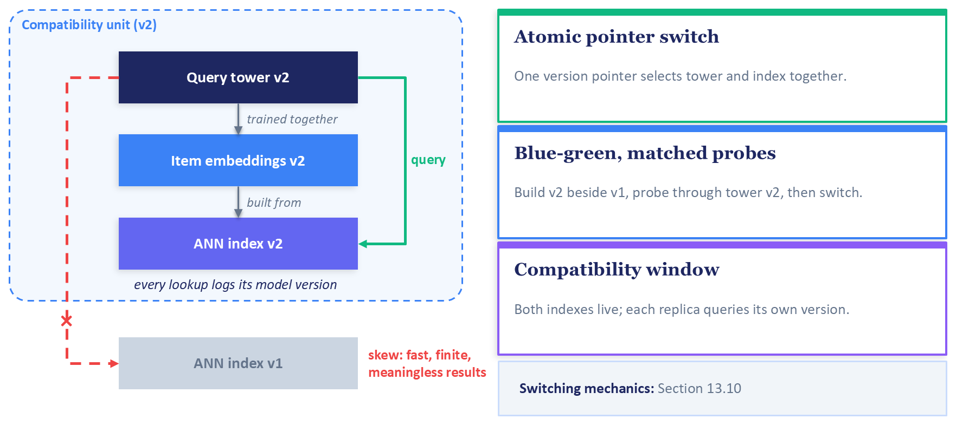
Figure 15.6: The query tower, the item embeddings, and the index form one compatibility unit that must be released together; a tower that queries an index from another version gets fast, finite, meaningless results. An atomic pointer switch, a blue-green build verified by probes through the matching tower, and a compatibility window with version-matched routing are three ways to release the unit. Every response reports the model and index versions that served it (Section 13.2.5), and the switching mechanics belong to Section 13.10.

15.9.5 Validation Gates and Safe Rollout
A new artifact reaches production through a sequence of gates, each of which answers a narrower question than the last.
Offline validation is the first gate and the cheapest. It should verify metric floors on a held-out window and on the important slices, particularly cold-start users and items, check calibration alongside accuracy, and re-run the leakage checks described in Chapter 3 and Chapter 6, since a leak that inflates offline metrics will present as an unexplained gap between offline and online results. The ML Test Score rubric, which Chapter 4 described, provides a checklist for what a production-ready model pipeline should be testing across data, model, infrastructure, and monitoring, and scores a system by its weakest category (Breck et al., 2017). Candidates from scheduled retraining and from automated research loops, such as the agentic loop of Appendix C that searches over training recipes offline, pass through the same gate, and each candidate's record should name both its model-registry version and the version of the evaluation code and data that judged it.
Shadow evaluation is the second gate. It runs on the shadow deployment of Section 13.10.3, and its criterion is a comparison of the new model's logged scores against the incumbent's on the same requests. This catches the failures that offline evaluation structurally cannot: missing features in the serving environment, encoder mismatches, latency regressions, and distributional differences between training data and live traffic. LinkedIn runs this as its dark canary phase, where engineers compare feature distributions between the training data and live inference before the model is ramped to serve members (Kumar et al., 2021).
Canary release is the third gate. Section 13.10 covers how a canary's share of traffic is assigned, raised, and rolled back while the current version serves the rest, and its release pipeline promotes a canary when the metrics look healthy; this section supplies those metrics and the judgment. Kayenta, the automated canary analysis system that Netflix open-sourced in partnership with Google, shows that judgment at work. It compares the canary against a freshly deployed baseline of the current version that receives an equal share, so that the two differ only in the change under test. It pairs the metric time series from the two clusters, applies a statistical test to each metric, and combines the results into an aggregate score, on which the pipeline continues the rollout, rolls back, or asks for manual intervention (Graff and Sanden, 2018).
A recommender canary holds three groups of metrics. The first is the service guardrails: error rate, p95 latency, and the fallback and contract-rejection rates that Chapter 13 names as rollback triggers (Section 13.10.4). The second is the label-free recommendation signals from Sections 15.4 and 15.5, compared between canary and baseline: feature default rates, the score distribution, candidate counts and per-source shares, contribution shares in the value function, and rank correlation through the policy layer. The third is fast behavioral outcomes that mature inside the window, such as play starts or clicks, with slower outcomes left to the experiments of Chapter 16. A canary window closes before most engagement labels mature, the problem Section 15.7 described, so the decision rests mainly on the guardrails and the label-free signals. The canary should run long enough to cover the traffic mix it compares, including the variation across hours of the day, and the maturation horizon of the fastest outcome it uses. Its rollback criteria, meaning which metrics, which thresholds, and how many failing metrics end the canary, are fixed before it starts, so the numbers that arrive during the canary cannot reshape the rule that judges them.
Data releases need the same treatment as code releases, particularly in a recommender, where catalog metadata changes continuously. Netflix describes a data canary for this purpose: new catalog versions are validated against a permanent baseline using production traffic. The team measures health with playback starts, a count of actual playback attempts, because a behavioral metric such as playback starts catches corrupted data that latency and error rates miss. When the canary detects a regression, publication of the bad data is blocked automatically (Amados, 2026). A recommender team can apply the same reasoning to embedding refreshes and index rebuilds, validating them against a behavioral signal before they reach users.
Champion-challenger operation is the steady state that these gates lead to. A challenger model runs continuously alongside the champion, on shadow traffic or on a small canary share, so that a validated alternative is always ready when the champion degrades. Establishing that a challenger is better than the champion, and deserves promotion on that ground, is a question for a controlled experiment of the kind Chapter 16 describes.
Section 13.10.3 separated the two questions: a canary asks whether a release is safe to complete, and an A/B test asks whether a change improves outcomes. For gate design, a canary is tuned to detect harm quickly with a small exposure, accepting statistical imprecision in exchange for speed, and the sample sizes, randomization discipline, and analysis that valid inference about an effect requires belong to Chapter 16. This chapter stops at the operational gate. Figure 15.7 joins the gates, the versioned artifacts, and the rollback paths into one loop.
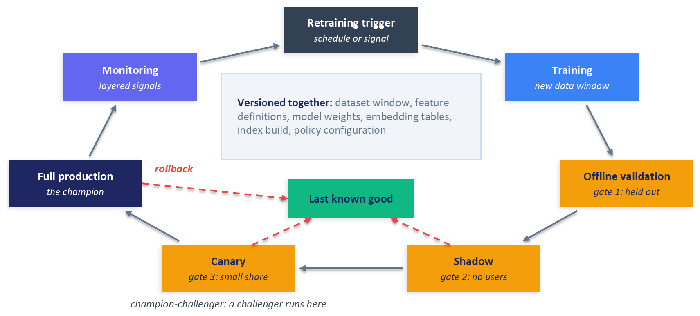
Figure 15.7: The artifact lifecycle with its validation gates. Each gate answers a narrower question than the one before it, and every stage that receives live traffic keeps a path back to the previous known good version.

15.10 Organizing for Operations
Monitoring and lifecycle discipline are socio-technical systems. A signal with no owner produces no action, and a runbook nobody maintains is worse than none, because it directs an engineer confidently toward a procedure that no longer works.
The layered framework provides a natural allocation of responsibility. Data engineering usually owns layer one and shares layer two with the recommender team. The recommender team owns layers three through six, since those are the artifacts it builds and the only team with the context to interpret them. Platform and infrastructure own layer seven, and product and analytics own layer eight, with the recommender team as a joint consumer. The essential rule is that every layer, and every alert within it, has exactly one owning team. Shared ownership of an alert reliably produces no ownership during the incident it was created for.
Escalation paths need to be written down before they are needed, because the layered structure means the team that receives an alert is frequently not the team that can fix the cause. A feature distribution alert fires to the recommender team and may resolve into an upstream data problem owned elsewhere, so the path from detection to the responsible party should be explicit and should not depend on knowing whom to message.
An operational readiness review before launching a new model or a new surface catches most of these gaps cheaply. The checklist is short: the service level indicators are defined and instrumented, the dashboards exist and someone has looked at them, a runbook describes the expected failure modes and their responses, the rollback path has been rehearsed, and an owning team is named for each alert.
Telemetry costs money, and the signals this chapter recommends are the expensive kind. Per-slice distributions across many features, per-stage candidate logging, and long retention for trend comparison all consume storage and query capacity. Sampling is the standard answer, and the important constraint is that the sampling design must preserve the important slices, since uniform sampling will faithfully preserve the traffic that was already well covered and lose the small segments where problems concentrate. Retention can usually be tiered, keeping raw sampled records for a short window for diagnosis and aggregated statistics for much longer for trend analysis.
None of this is free of organizational effort, and the interview study cited earlier found the same: sustaining production model quality involved maintaining multiple evaluation datasets and metrics over time, ensuring the subpopulations of interest stayed covered, and relying on human review and simple non-model rules alongside the automated machinery (Shankar et al., 2022). A team that treats monitoring as a tooling purchase, with no ongoing work planned, will find the tooling accurate and unread.

15.11 A Silent Failure You Can Reproduce, and a Summary
The companion exercise for this chapter reproduces the opening incident offline. It retrains the gradient-boosted ranker from Chapter 6, with the same feature pipeline, on the 30 days of Yambda data before the dataset's final day and scores that final day, with no serving stack and no cloud infrastructure, and its code sits in the chapter15_recsysops folder of the companion repository.
The exercise first ranks the model's features by importance and selects the two most important non-identifier features. It scores a reference day, the last day of the 30-day window, which the model neither trains nor early-stops on, and the uncorrupted test day that follows, which gives each scenario both a baseline and an untouched control across ranking quality, calibration, and score distribution. It then runs three corruption scenarios on the test day, each applied in the serving path only, leaving the trained model untouched. The first replaces the selected feature columns with zeros for all traffic, which is the corruption from the opening scenario. The second applies the same zero-fill to a fixed fraction of users, chosen by a hash of the user identifier, so that the damage inside the affected segment can be compared against what the overall aggregate shows. The third replaces the columns with their training-set means. Mean-fill introduces no nulls and no zeros and leaves the mean of each column close to its normal value, so monitors that alarm on rising nulls, rising zeros, or a shifted mean should stay quiet; the constant column has also lost its spread, which quantile, Kolmogorov-Smirnov, and population stability index checks can see. The third scenario is built to test that distinction.
For each scenario, and separately for the affected segment and the aggregate, the exercise records which of the feature signals from Section 15.4 and the score distribution from Section 15.5.2 fire and which stay green, and adds ranking quality and calibration once labels are joined. Schema validation, row counts, and join rates are expected to stay green by construction, since the corruption is applied after the joins and changes values without changing shape; in the opening incident the defaults came from a join that stopped matching, so a match-rate check on that join would have fired. Because the selected features are user-level aggregates, constant across one user's candidates, the corruption shifts each user's scores together, so AUC over all rows and calibration fall sharply while the per-user ranking metrics move far less. Corrupting item-level features instead, an option in the exercise, barely moves pooled AUC, while group AUC falls by about as much as it does under the user-level corruption. Service metrics such as throughput and error rate are unaffected by construction, because no serving code changes, so the exercise does not measure them. The design sets label-free signals against label-dependent ones, and segment views against the aggregate, and the exercise's design notes record what each run produced.
Stepping back, this chapter began with a system that was running perfectly and recommending badly, and it has worked through what it takes to notice. Recommendation health is distinct from service health, and it decomposes into layers that can each be instrumented, from upstream events to the slate the user finally sees. Failures travel along that stack while symptoms appear at the end of it, so localization requires signals at every layer and the sampled per-stage logging that makes them comparable. Change over time comes in several kinds that demand different responses, and detecting a change is not the same as establishing harm. Outcomes arrive late and are shaped by the policy under judgment, which limits how quickly anything can be confirmed. Alerts are only useful with owners and prepared responses, and most of those responses return some artifact to a previous version, which makes versioning the model, the embeddings, the index, and the policy configuration an operational requirement.
What remains is the question this chapter deliberately declined to answer. Monitoring establishes that something changed and helps locate where. It does not establish that a deliberate change is an improvement, because the traffic it observes was never randomized and the comparisons it makes were never designed for inference. Chapter 16 takes up controlled experimentation, the statistics of online tests, and the exploration policies that address the feedback loop described in Section 15.2.3.

References
Amados, C. (2026). "The Data Canary: How Netflix Validates Catalog Metadata." Netflix Technology Blog. https://netflixtechblog.com/the-data-canary-how-netflix-validates-catalog-metadata-18b699d58e36
Baylor, D., Breck, E., Cheng, H.-T., Fiedel, N., Foo, C. Y., Haque, Z., Haykal, S., Ispir, M., Jain, V., Koc, L., Koo, C. Y., Lew, L., Mewald, C., Modi, A. N., Polyzotis, N., Ramesh, S., Roy, S., Whang, S. E., Wicke, M., Wilkiewicz, J., Zhang, X., and Zinkevich, M. (2017). "TFX: A TensorFlow-Based Production-Scale Machine Learning Platform." Proceedings of the 23rd ACM SIGKDD International Conference on Knowledge Discovery and Data Mining. ACM. https://doi.org/10.1145/3097983.3098021
Bernardi, L., Mavridis, T., and Estevez, P. (2019). "150 Successful Machine Learning Models: 6 Lessons Learned at Booking.com." Proceedings of the 25th ACM SIGKDD International Conference on Knowledge Discovery and Data Mining. ACM. https://doi.org/10.1145/3292500.3330744
Beyer, B., Jones, C., Petoff, J., and Murphy, N. R. (Eds.). (2016). Site Reliability Engineering: How Google Runs Production Systems. O'Reilly Media. https://sre.google/sre-book/table-of-contents/
Breck, E., Cai, S., Nielsen, E., Salib, M., and Sculley, D. (2017). "The ML Test Score: A Rubric for ML Production Readiness and Technical Debt Reduction." 2017 IEEE International Conference on Big Data. IEEE. https://research.google/pubs/the-ml-test-score-a-rubric-for-ml-production-readiness-and-technical-debt-reduction/
Chaney, A. J. B., Stewart, B. M., and Engelhardt, B. E. (2018). "How Algorithmic Confounding in Recommendation Systems Increases Homogeneity and Decreases Utility." Proceedings of the 12th ACM Conference on Recommender Systems. ACM. https://doi.org/10.1145/3240323.3240370
Chapelle, O. (2014). "Modeling Delayed Feedback in Display Advertising." Proceedings of the 20th ACM SIGKDD International Conference on Knowledge Discovery and Data Mining. ACM. https://doi.org/10.1145/2623330.2623634
Chitlur, S., and Csernai, K. (2021). "Maintaining Machine Learning Model Accuracy Through Monitoring." DoorDash Engineering Blog. https://careersatdoordash.com/blog/monitor-machine-learning-model-drift/
Egg, A. (2021). "Online Learning for Recommendations at Grubhub." Proceedings of the 15th ACM Conference on Recommender Systems. ACM. https://doi.org/10.1145/3460231.3474599
Gama, J., Žliobaitė, I., Bifet, A., Pechenizkiy, M., and Bouchachia, A. (2014). "A Survey on Concept Drift Adaptation." ACM Computing Surveys, 46(4), 1–37. https://doi.org/10.1145/2523813
Graff, M., and Sanden, C. (2018). "Automated Canary Analysis at Netflix with Kayenta." Netflix Technology Blog. https://netflixtechblog.com/automated-canary-analysis-at-netflix-with-kayenta-3260bc7acc69
Guo, C., Pleiss, G., Sun, Y., and Weinberger, K. Q. (2017). "On Calibration of Modern Neural Networks." Proceedings of the 34th International Conference on Machine Learning. PMLR. https://arxiv.org/abs/1706.04599
Kaminskas, M., and Bridge, D. (2016). "Diversity, Serendipity, Novelty, and Coverage: A Survey and Empirical Analysis of Beyond-Accuracy Objectives in Recommender Systems." ACM Transactions on Interactive Intelligent Systems, 7(1), 1–42. https://doi.org/10.1145/2926720
Kumar, R., Das, D., Nagpal, S., Gupta, S., and Singh, V. (2021). "Model Health Assurance Platform at LinkedIn." LinkedIn Engineering Blog. https://www.linkedin.com/blog/engineering/analytics/model-health-assurance-at-linkedin
Liu, Z., Zou, L., Zou, X., Wang, C., Zhang, B., Tang, D., Zhu, B., Zhu, Y., Wu, P., Wang, K., and Cheng, Y. (2022). "Monolith: Real Time Recommendation System With Collisionless Embedding Table." 5th Workshop on Online Recommender Systems and User Modeling, held with the 16th ACM Conference on Recommender Systems. https://arxiv.org/abs/2209.07663
Lundberg, S. M., and Lee, S.-I. (2017). "A Unified Approach to Interpreting Model Predictions." Advances in Neural Information Processing Systems 30. Curran Associates. https://arxiv.org/abs/1705.07874
Rabanser, S., Günnemann, S., and Lipton, Z. C. (2019). "Failing Loudly: An Empirical Study of Methods for Detecting Dataset Shift." Advances in Neural Information Processing Systems 32. Curran Associates. https://arxiv.org/abs/1810.11953
Saberian, E., and Basilico, J. (2022). "RecSysOps: Best Practices for Operating a Large-Scale Recommender System." Netflix Technology Blog. https://netflixtechblog.medium.com/recsysops-best-practices-for-operating-a-large-scale-recommender-system-95bbe195a841
Saberian, M., and Basilico, J. (2021). "RecSysOps: Best Practices for Operating a Large-Scale Recommender System." Proceedings of the 15th ACM Conference on Recommender Systems, 590–591. ACM. https://doi.org/10.1145/3460231.3474620
Sculley, D., Holt, G., Golovin, D., Davydov, E., Phillips, T., Ebner, D., Chaudhary, V., Young, M., Crespo, J.-F., and Dennison, D. (2015). "Hidden Technical Debt in Machine Learning Systems." Advances in Neural Information Processing Systems 28. Curran Associates. https://papers.neurips.cc/paper/5656-hidden-technical-debt-in-machine-learning-systems
Shankar, S., Garcia, R., Hellerstein, J. M., and Parameswaran, A. G. (2022). "Operationalizing Machine Learning: An Interview Study." arXiv preprint arXiv:2209.09125. https://arxiv.org/abs/2209.09125
Shukla, A., Nath, K., Vats, N., Tatipathri, V., and Jagannathan, D. (2023). "D3: An Automated System to Detect Data Drifts." Uber Engineering. https://www.uber.com/us/en/blog/d3-an-automated-system-to-detect-data-drifts/
Yurdakul, B. (2018). "Statistical Properties of Population Stability Index." Doctoral dissertation, Western Michigan University. https://scholarworks.wmich.edu/dissertations/3208

